Name: Rohitashav Aggarwal
Configuring and Managing Resource Access
Encrypt Files
- Create a new folder in file explorer within the Documents folder
- Create a file inside the folder
- Right click on the folder to access properties and click the Advanced button
- Check the encrypt contents to secure data and click ok
- Click apply
- Set who owns this folder
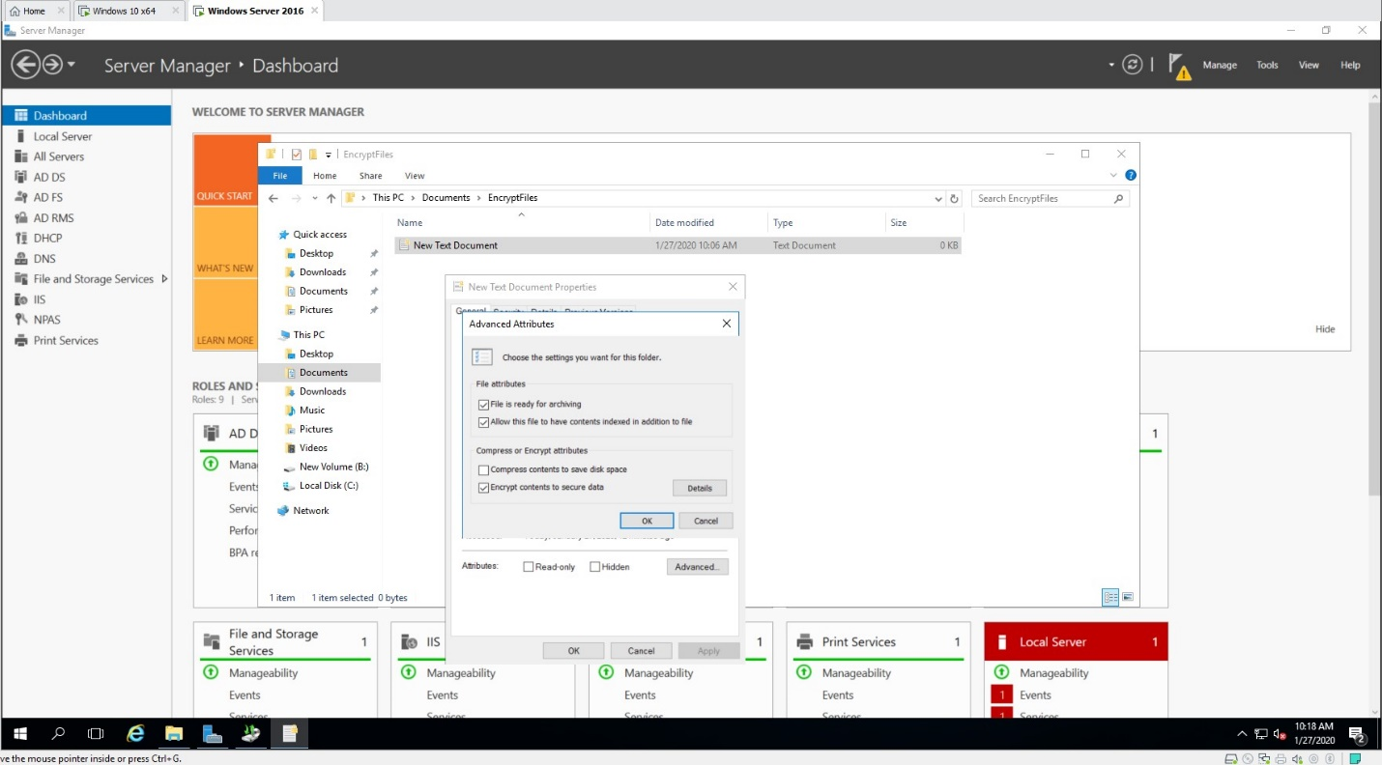
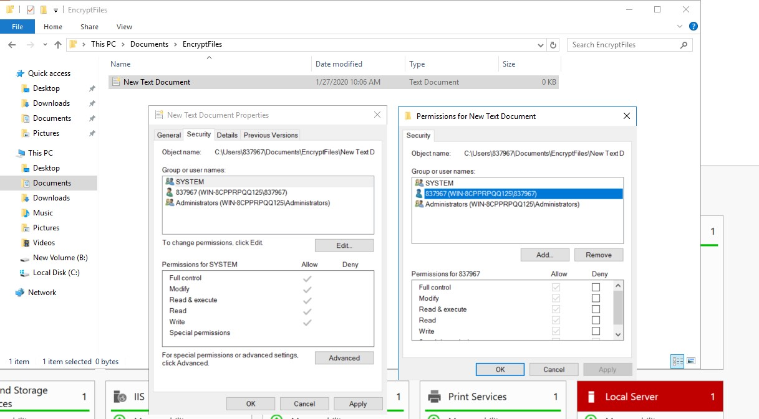
Configure Folder Permissions
- Create a new folder in file explorer within the Documents folder
- Create a sub folder
- Add the Server Operations Group and allow this group to modify
- Remove inherited permissions
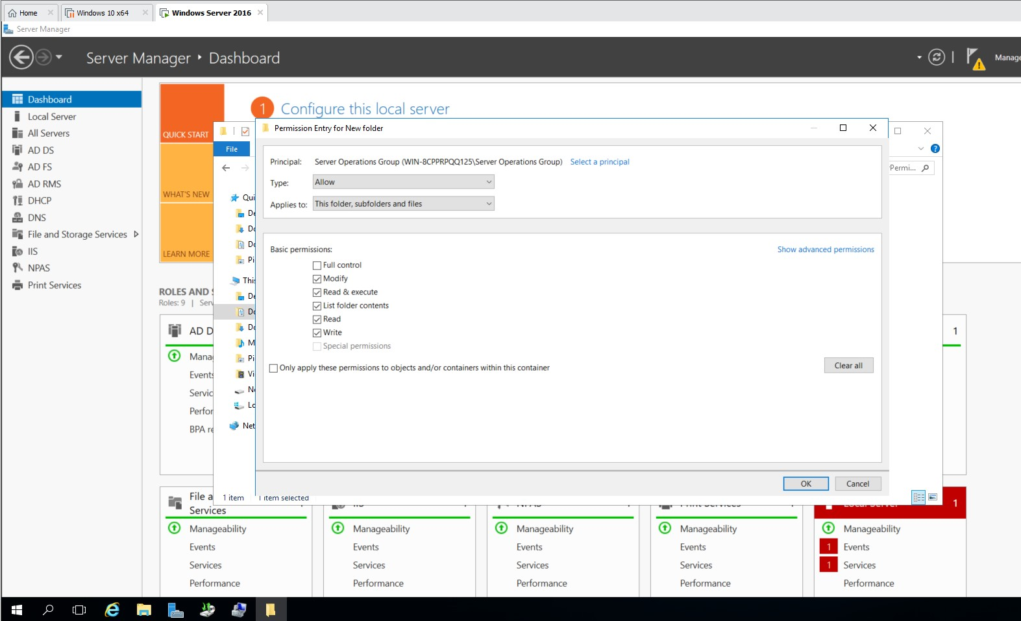
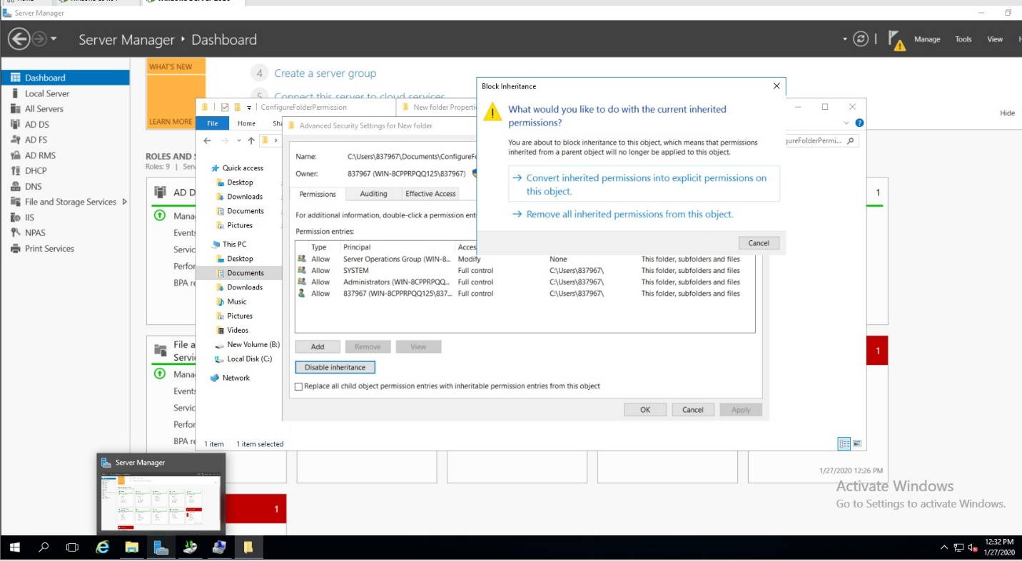
Configure Advanced permissions
- Create a new folder in file explorer within the Documents folder
- Create a sub folder
- Add a domain group to security permissions
- Go to advanced permissions
- Allow permissions should be set for Create files/Write data, Create folders/append data, Delete subfolders and files and Delete
- Choose Only apply these permissions to objects and/or containers within this container
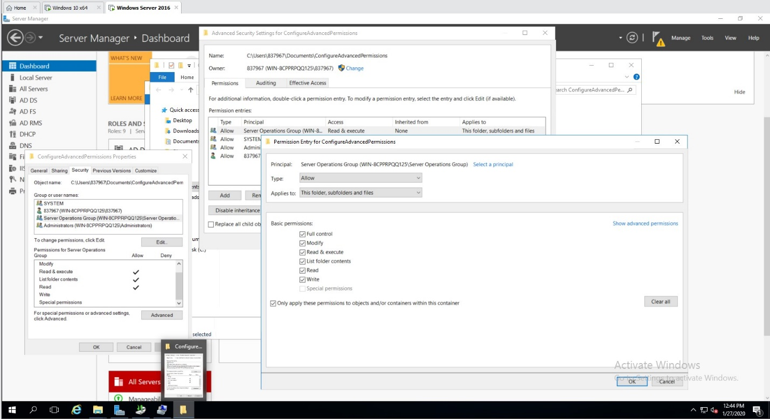

Create Shared folder and publish on AD
- Install File and Storage Services
- Ensure File and Storage services, File and iSCSi Services and File Server are ticked
- In the left pane of Server Manager click File and Storage Services
- Click Shares
- Click down arrow for Tasks and click new share
- Choose SMB share – advanced and click next
- Choose the folder you want to share
- Allow caching of share
- Click Customize permissions
- In the advanced security settings for the folder window click share tab
- Click Add
- Select a principal, then advanced and choose a group from AD and ensure type is Allow and access is set to full control
- Remove Everyone from the permission list
- Go to server manager, tools and click on Active Directory User and Computers
- Right click on an OU that belongs to the IT Team within AD Tree
- Point to New
- Click Shared Folder
- Enter the path of the shared folder
Configure Disk Quotas
- Open Server Manager
- Click Tools and click File Server Resource Manager
- Go to Quota Management and double click Quotas
- Create a Quota limit of 200MB. Choose the folder you would like to set quota on

